Recommendations for Spike Sorting using Plexon Sort Client and Offline Sorter
Updated 06-16-12
Alexxai Kravitz
Kreitzer Lab

Please read the Offline Sorter Manual here: http://www.plexon.com/product/Offline_Sorter.html. The Offline Sorter manual has detailed information on all aspects of the software, while this document is designed to cover the theory underlying spike sorting, how I sort spikes with Offline Sorter, and how to quantify sorting quality.

Background:
Chronic extracellular recording is a powerful tool for correlating changes in neuronal firing with changes in the behavior or environment of an animal. With this technique, it is possible to isolate spikes from a single unit or to record “multiunit” activity from several units together. Depending on the experimental goals, multiunit activity may be as useful as single unit activity, and is easier to acquire. Identifying multiunit activity in the recording is also useful for statistical quantification of the quality of single unit recordings (ie: are the “single unit” waveforms statistically different from the “multiunit” waveforms?). This document will cover the theory underlying spike sorting, how to process data in Plexon Sort Client and Offline Sorter, and how to quantify the quality of single unit recordings.

Spike sorting:
Spike sorting consists of the following steps, which will each be reviewed in more detail in the following sections:
- Data acquisition
- Identifying candidate neural activity in the recording
- Limiting data to be analyzed
- Calculate metrics of waveform shape
- Generate and sort clusters
- Evaluate clusters to determine if they contain single or multiunit activity

1. Data acquisition:
I won’t talk much about data acquisition, but this is a section that maybe expanded later if necessary. A good reference book for chronic extracellular data acquisition is [1] (full book is text available online). We will start with the assumption that electrical noise in the recording has been mitigated, and there are good units on the electrodes.

2. Identifying candidate neural activity in the recording
This process is done “online” with the Plexon SortClient. As this literally affects what data is written to disk with the MAP system, it is not possible to redo this process “offline” after the recording is completed. Note: With an Omniplex system it is possible to record wideband signals and redo this thresholding step at a later point, but either way it is faster to set this as best as possible before recording. If we examine the analog signal on any given extracellular electrode we will see a voltage trace like this (images in this section adapted from [2]):
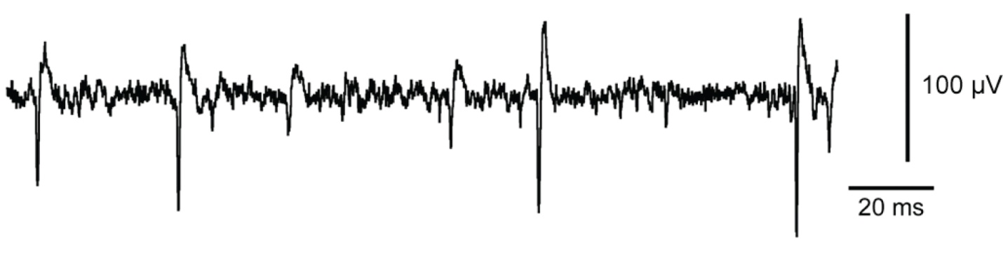
This trace appears to have one large unit (marked in blue), one smaller unit (marked in green), several even smaller events (marked in orange), and very small deflections that we will call “noise”:
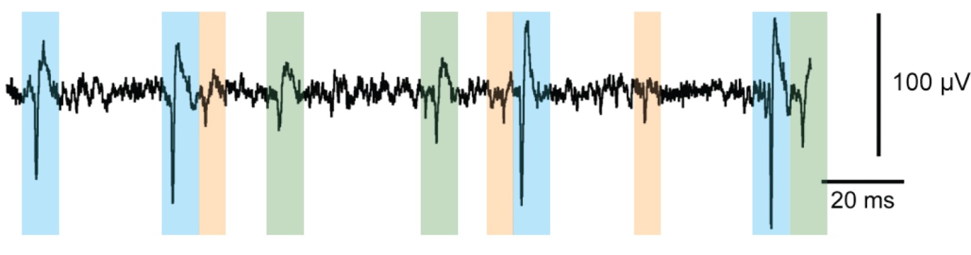
It saves a lot of data processing to discard the very small noise. So during acquisition (in SortClient), we select a threshold size for candidate non-noise waveforms. For example, the following threshold will identify 4 large events, which likely correspond to a single large unit on the recording. However, this threshold level will throw out the smaller unit, as well as the other small deflections (Again, as Sort Client only writes data larger than the threshold to disk, it will not be possible to rethreshold “offline” and examine these smaller events).
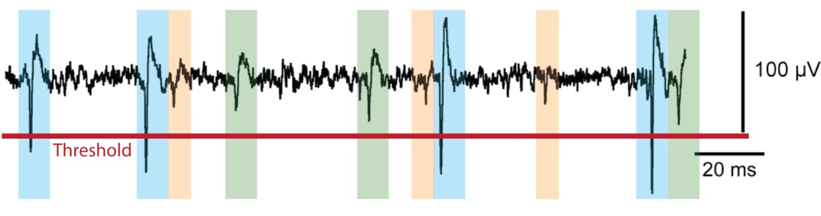
So a more appropriate threshold might be here:
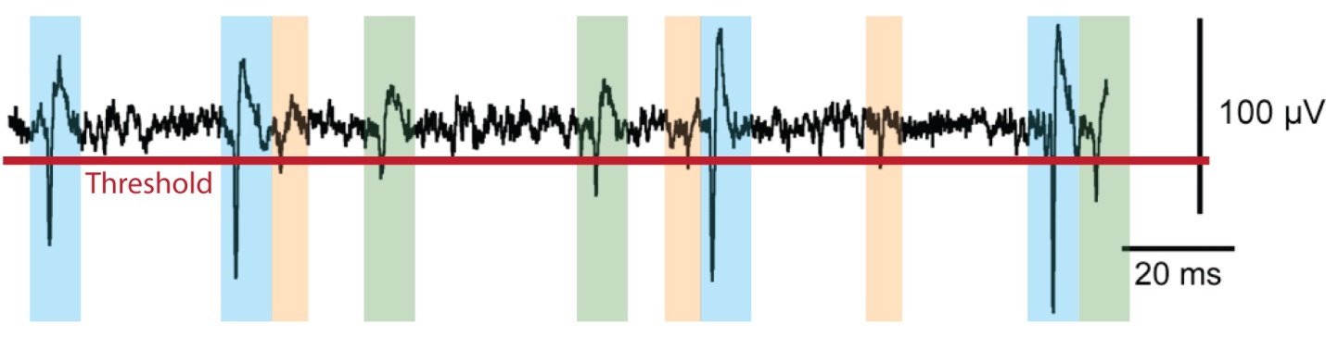
This threshold will identify 10 large amplitude events: 4 from the large unit, 3 from the small unit, and 3 even smaller events.

As one final note, you don’t want to set the threshold too loose such that you’re capturing everything, as this will impair the SortClient’s ability to acquire large events accurately. Briefly, SortClient acquires non-overlapping waveforms, triggered on when they cross the threshold, so if the threshold is set too loose it may acquire a small deflection and miss the larger neural spike. Setting the threshold too loose will also greatly increase the file size, which is a concern as the files can already get pretty unwieldy to work with as is (they often exceed 1GB).
3. Limiting data to be analyzed

- Limit time period of cluster sorting to actual analysis windows
In practice, we often record much more data than we use in our final analysis. This can include extended baseline periods before or after the recording, or manipulations that end up not being useful and are excluded from the analysis of each unit. Because of waveform variability and drift, these “unused” time periods will add variability to the cluster sorting, and removing them will clean things up. Often the actual analysis periods may not be known up front, but once these are known it is worth the effort to redo the spike sorting on just the analyzed time periods. This is one of the best ways to improve cluster sorting in a recording.

To select which periods you want to retain before cluster sorting click Tools>Interval Selection:
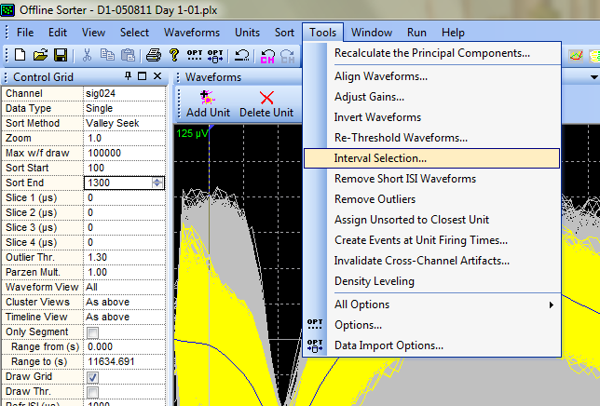

The following options will pop up, which you can use to invalidate waveforms outside of your desired time periods:
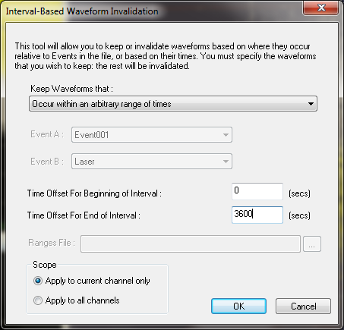

- Artifact rejection
Despite using differential recording (the signal from each electrode is subtracted from a reference electrode) artifacts can still occur on all channels. These can be movement related or generated by nearby equipment. While it is best to mitigate these issues before recording, this is not always possible. Instead, these must be “invalidated” afterwards. Offline Sorter retains “invalidated” waveforms, but will not visually display or include them in any future analyses. This is important because they can interfere with your ability to see the clustering of more relevant waveforms, as well as statistical analyses of these waveforms if left in.
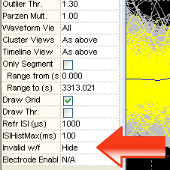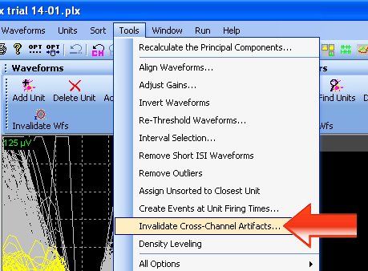
First, make sure the Invalid w/f setting is set to ‘hide’. Then, to invalidate artifacts, select Tools > Invalidate Cross Channel Artifacts.

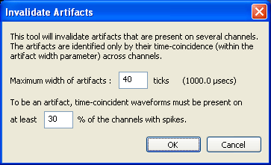
This brings up the following dialog window, which I set as follows:

These values can be changed

if necessary, but I find that these values (40 ticks, 30%) work well and would recommend not changing them to keep the processing consistent with other data. After clicking OK it will ask you again if it’s OK to invalidate the artifacts. Depending on the file size, this step can take a while (up to 30 minutes), and you might not get any feedback from Offline Sorter that it’s doing anything. It may look frozen up but it’s not - just let it run until it’s done.
Manually invalidating waveforms
It is also possible to manually invalidate additional waveforms in any channel using this tool:

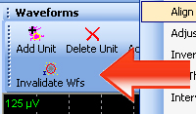

While it is best to avoid manual adjustments, this tool can be useful for quickly removing waveforms that are clearly outliers or artifacts but aren’t identified with the cross channel artifact rejection tool.

A note on aligning waveforms:
Another tool which can be useful is called Align Waveforms. As they are acquired, all waveforms are temporally aligned to when they cross the threshold level, but in some cases it can be helpful to align them to their absolute minima instead. In practice, I use this sparingly as it only helps in rare situations (and can sometimes make things worse), and it takes several minutes of processing for Offline Sorter to complete this step.

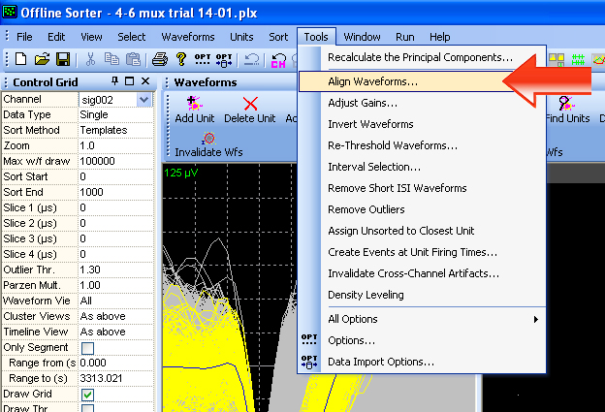

4. Calculate metrics of waveform shape
After identifying all candidate neural waveforms and rejecting artifacts, you are left with a bunch of waveforms that need to be grouped by shape. This is essentially a classification problem, where we’d like to identify 2 or 3 variables that uniquely identify each waveform we’ve collected, and then draw a scatter plot of these variables to visualize the different classes of waveforms as different clusters. If you click here you will see several variables that can be used to identify differences between the collected waveforms:
Using PCA for Spike Sorting

Plexon digitizes 56 points for each recorded waveform. If it only collected 3 points we could represent all of the waveform data in a 3D scatter plot, where similar waveforms would cluster in similar locations in 3D space. However, 3 points would not contain very much information about the shapes of the recorded waveforms.

Digitizing 32 points is great for identifying unique waveform shapes, but unfortunately we can’t make a 32-dimensional scatter plot to visualize this 32 dimensional data. However, we can project the 32-dimensional data into a lower dimensional subspace using a technique called principal component analysis (PCA). PCA is a mathematical technique that rotates high dimensional data around in high dimensional space to find axes that capture the most variance in the data. These new axes contain information from several of the original axes and don’t have easily definable units (ie: mV, sec). PCA axes are very similar to linear regression lines in 2D scatter plots, which contain information from each of the original two dimensions and also don’t have easily defined units.

A detailed overview of principal component analysis can be found here: http://en.wikipedia.org/wiki/Principal_component_analysis
A conceptual video animation for PCA can be found here: http://www.youtube.com/watch?v=BfTMmoDFXyE
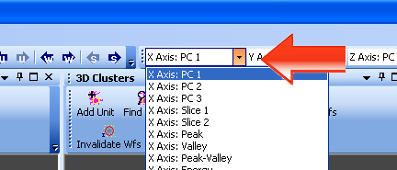
You can set a different variable for the X, Y, and Z axes and view the resulting scatter plot. In practice, I always leave these variables set to PC1, PC2, and PC3. These correspond to the first 3 principal components of a matrix where each recorded waveform is a row, and each of the 32 digitized points of each waveform is a columns (see sidebar). In both theory and practice I have found principal component analysis (PCA) to be the best way to discriminate different waveform clusters, and this is by far the most widely used in the literature.

5. Generate and sort clusters

Despite the online sorting, all clusters should be re-sorted in the Offline Sorter. To sort units, click ‘Add Unit’, and circle the cluster of points for each unit. Finer adjustments can be made with the ‘Add Wfs’ and ‘Remove Wfs’ buttons.

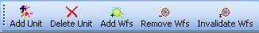
Once you have the putative clusters identified, use the ‘Template Sort’ feature to let Offline Sorter assign spikes to each unit. This method uses a simple nearest neighbor matching algorithm in PCA space. 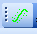
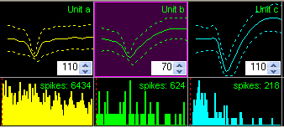
The stringency of each cluster can be adjusted by setting thresholds on the unit templates below the waveform view. Continue adding and removing waveforms, and adjusting the template stringency until you’re happy with the cluster sorting.

For consistency, sort the multiunit activity as unit A, and putative single units as units B, C, D, etc. Even if you’re not interested in multiunit activity, it is important to define the multiunit activity as a unit so that the software can make statistical comparisons of unit quality.

For channels that only have “multiunit” activity (as in the example below), depending on your final analyses it still may be useful to select it and export timestamps.

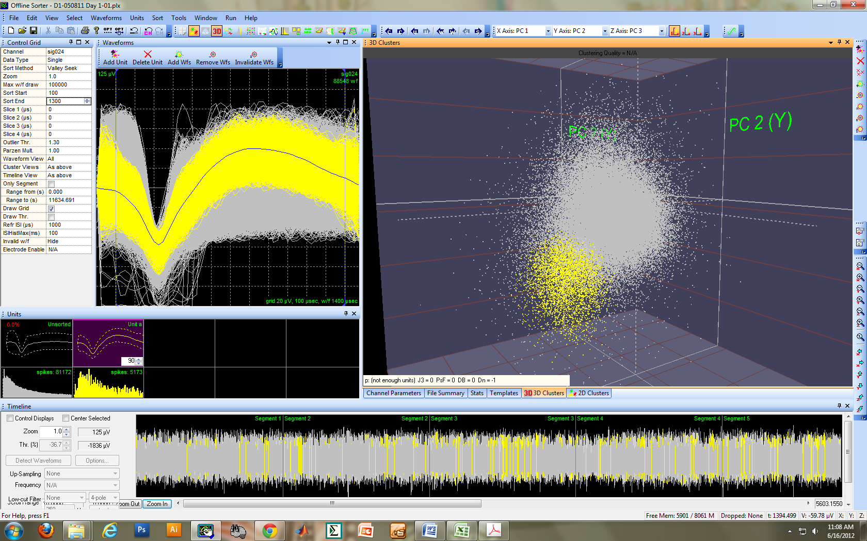

A note on automated sorting:
Not surprisingly, there are automated methods for sorting spikes (Offline Sorter has several automated methods in the Sort menu that can be tried). However, due to the heterogeneous nature of spike sorting problems, it is difficult for these methods to work accurately in all situations. Most researchers use a hybrid method where the clusters are identified in a highly supervised manner, but the computer selects the actual spikes that belong in each cluster.

6. Evaluate clusters to determine if they contain single or multiunit activity

To start with, two simple parameters should minimally be satisfied for all putative single units. In general, the electrodes we use record ~30uV peak-peak noise band. I look for units that are at least 3x this noise band, or ~90uV at a minimum. The amplitude of sorted clusters can be estimated from the grid on the 2D waveform view. Plexon also allows you to set a reference inter-spike-interval period, and calculates the % of spikes that violate this period. I set this to 1msec, and look for no more than 0.1% of all spikes to violate this. This number appears in the top left of the waveform template. The exact number of violations can also be found in the View>Info Grid Views>Stats page.

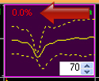

If a putative unit cluster does not satisfy these two conditions, I add it into the multiunit “unit a” at this point. On any recording channel, there may be single unit activity, multiunit activity, and “noise”. For this purpose, the statistical comparison that is most meaningful is whether the single unit is significantly separated from the multiunit activity, which we are defining as unit a. To get Offline Sorter to calculate clustering statistics, first go to Tools>Options>Stats and click on the options to calculate stats after each change, and calculate advanced stats.

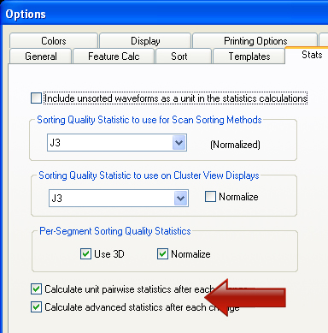

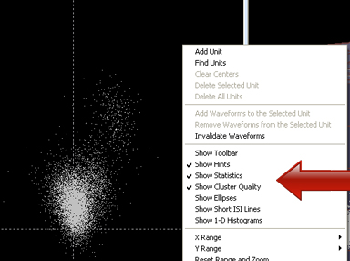
To visualize the stats in real time as you sort you have to turn on two options in the “right click” menu. To access this menu, hold the ‘Alt’ key as you right click over the 2D cluster view. Click on ‘Show Statistics’, and ‘Show Cluster Quality’. Finally, it is useful to keep the View>Info Grid Views>Stats page open at all times to view the pairwise stats between all clusters.

This will place 5 sorting statistics in a bar directly below the cluster scatter plots. These statistics are a MANOVA, J3, PseudoF, Davies-Bouldin, and Dunn statistics. A great overview of these statistics, and how to evaluate them can be found here (especially see supplemental text): [3]. Information on how these statistics are calculated is also in section 5-27 of the Offline Sorter manual. Here are some rules of thumb for using these stats to evaluate clusters.

In brief, the goal here is to compare each putative single unit cluster to the multiunit cluster, and decide if it is significantly different enough to call a single unit. The MANOVA performs a parametric statistical test of whether the multivariate data in each cluster is significantly different from the other clusters. At a minimum, the pairwise stats between the multiunit ‘unit a’ and any putative clusters should always be significant. This is really the only “necessary” statistic that I use for determining if a cluster is a single unit. However, it is useful to look at the other statistics.

The J3 statistic describes a ratio of within cluster to between cluster variance. In general, values over 1 are good, and values under 1 are bad. However, when the multiunit cluster is very large (if it contains a few “almost” single units in it) and the single unit is compact, the J3 value will be low. Therefore, I won’t exclude a unit for a low J3 value. The PseudoF stat is a normalized version of the J3, while the Davies-Bouldin and Dunn stats are alternative ratios of within-cluster to between cluster variance. In general, D-B values below 0.5 reflect good clustering, and values above 0.5 represent poor clustering. However, the J3 appears to be a better indicator of this [3].

In summary, a “single unit” should satisfy the following requirements:
- Amplitude greater than 90uV
- Less than 0.1% of spikes violating a 0.1sec ISI
- Significant pairwise MANOVAs between all clusters
- While not necessary, a J3 >1 is also an indicator of good clustering.

Despite these stats not being “necessary” for single unit identification, a good recommendation from [3] is to report the average and distribution of J3 and D-B values for all sorted “single units”. This can be exported for each channel from Offline Sorter (see below).

When you are done, you can export 4 things:

- Export the file to a new .PLX. In this step I like to unclick the ‘Export Invalidated Waveforms’ option to discard all of the waveforms you invalidated that were artifacts, and those that are outside your analysis windows. For the purposes of data sharing this is a much nicer file to give someone, instead of explaining why certain data was invalidated and how they can replicate your invalidation steps.

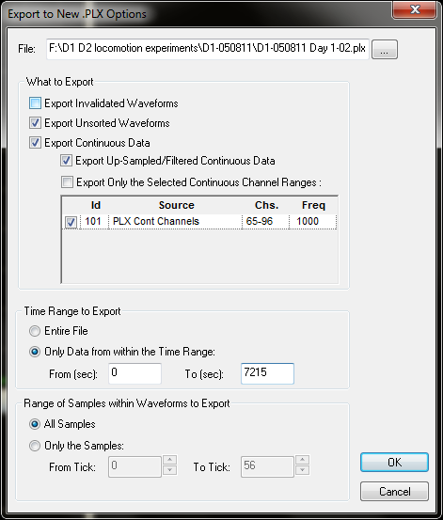

- Export a Nex file that can be easily opened in Neuroexplorer. In Neuroexplorer, remember that all ‘a’ units are multiunit activity. These can be deleted in Neuroexplorer if you know you won’t use them.

- Export the unit waveforms to an excel sheet by clicking File>Export Per-Unit Data. Also click ‘All Channels into one file’.
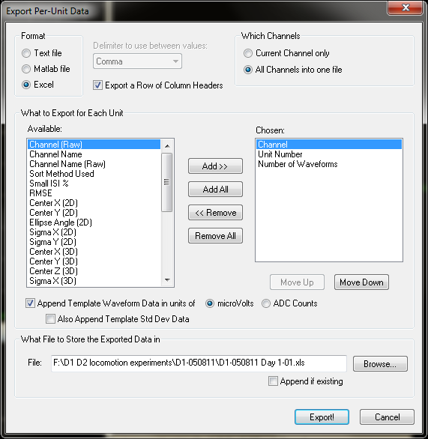
- Finally, export summary sorting statistics to the same excel sheet by clicking File>Export Per Channel Data. If you don’t change the name this will append these stats to your waveform sheet, where you can set up some simple calculation columns to generate waveform amplitudes, durations, and average sorting stats for each experiment.

References

1. Methods for Neural Ensemble Recordings. Edited by Nicolelis MA. Boca Raton, FL: CRC-Press; 1998.
2. Shoval A, Adams C, David-Pur M, Shein M, Hanein Y, Sernagor E: Carbon nanotube electrodes for effective interfacing with retinal tissue. Front Neuroengineering 2009, 2:4.
3. Nicolelis MA, Dimitrov D, Carmena JM, Crist R, Lehew G, Kralik JD, Wise SP: Chronic, multisite, multielectrode recordings in macaque monkeys. Proc Natl Acad Sci U S A 2003, 100:11041-11046.

